Add animations to slides​

Add animations to slides​
Add animation to pictures, shapes, text boxes, and more to help bring your PowerPoint slides to life.
Choose an animation
- Select an object, press Shift, and then select the rest of the objects in your slide if needed.
- Select Animation > More to view the three animation types:
  - Entrance: Control how an object appears on a slide.
  - Emphasis: Control what happens to the object while it’s already on the slide.
  - Exit: Control how an object leaves a slide.
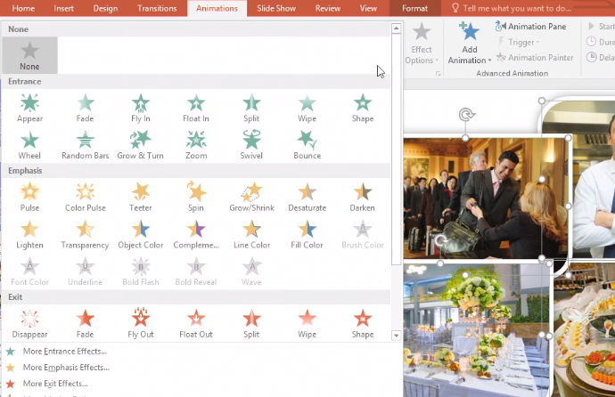
- Select an animation to use.
Change animation settings
- Select Animation Pane.
- To determine when and how each animation will happen, select an object, and then select its drop-down arrow.
- Select an option for each animation:
  - Start On Click: Make an animation start with a click.
  - Start With Previous: Make an animation start at the same time as the previous one.
  - Start After Previous: Make an animation start after the previous one happens.
- To reorder an object, select it and then select the Up and Down Arrows in the Animation Pane.
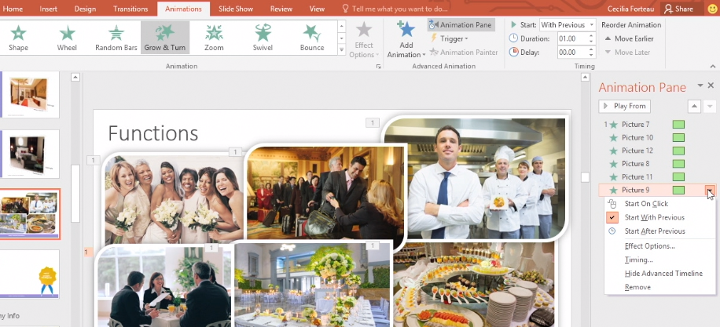
Change multiple animation settings at once
- To change all animations at once, select an animation, press Shift, and then select the last animation. You now have several options:
  - To speed up or slow down an animation, change the number in the Duration box.
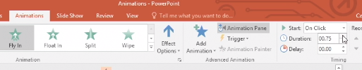
  - To determine when animations appear with a click, select Trigger > On Click of, and then select an object.
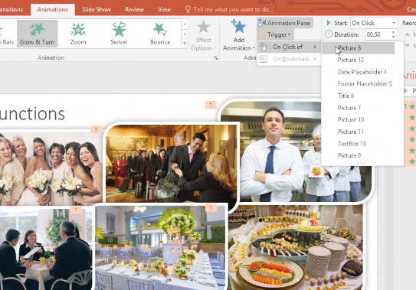
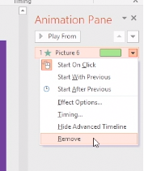
  - To add multiple animation effects, select Add Animation.
  - Select Preview to playback your animations.
Delete an animation
- Right-click the animation in the Animation Pane and select Remove.
Or, select an animation from the top of the slide and press Delete.

Add Excel tables to slides
In PowerPoint, you can embed tables and worksheets from Excel in your presentation slides.
- Select New Slide.
- In Excel, click and drag to highlight the cells you want to copy.
- Right-click the copied cells and select Copy.
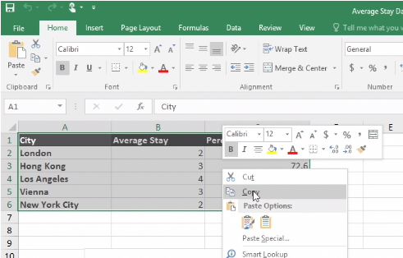
- In your PowerPoint presentation, right-click and select the Paste Options you want:
  - Use Destination Styles – Choose to edit your copied cells like a PowerPoint table, but with PowerPoint's color scheme and fonts.
  - Keep Source Formatting – Choose to keep your table editable in PowerPoint while maintaining the same source formatting from Excel.
  - Embed – Choose to keep a copy of your table in PowerPoint in case you want to edit the data, which will open in Excel.
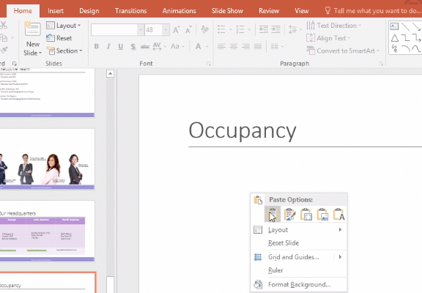
Note: If you're working with a large Excel file, it'll inflate your PowerPoint presentation to a big size. You may also unintentionally be giving more access to your Excel file than you intend to.
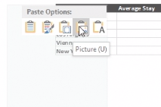
  - Picture – Choose to paste your table as a picture to get the same benefits as embedding except you can format your cells like a picture and add effects to it. You won’t be able to edit data once it’s been pasted though.
  - Keep Text Only – Choose to paste your table as straight text and to do all formatting in PowerPoint.

- If you pasted as a picture, on the Picture Tools Format tab, select the quick picture style you want to use. Adjust the table to your liking.

